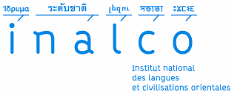

SWORN STATEMENT
(For visiting scholars)

I, ……………………….. ,
First Name – Last name - status
employed by ,
^{Employer}

hereby declare on my honour that I shall recieve no funding from my current employer/institution for my travel or lodging regarding my participation to the workshop « Journeys across the realm of the Dead : Narratives, ritual and images» that will take place in Inalco, Paris, from

Date and signature

