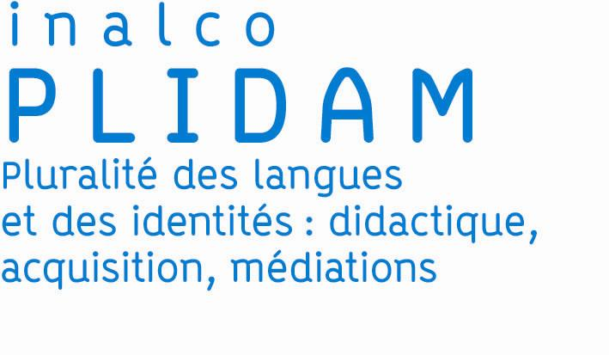
Symposium of June 13-14, 2019, Inalco / Plidam
"Language learning of allophone learners and innovative pedagogies"
Antonella Corvaglia and Françoise Wolf-Mandroux
The various situations linked to the intensification of the exchanges within contemporary societies lead to renew the modes of contact between languages ​​and create/contribute to the emergence of new communities of learners affected by personal and collective stories.
Any debate on the teaching and learning of foreign languages ​​and cultures concern, in some way, the effects of migration and the difficulties of integration.
The aim of this symposium is to stimulate an international debate on second-language learning practices for better inclusion and social integration of migrants in France, and other countries in Europe and the world. It aims at collecting testimonies from teachers, senior lecturers and specialists from different countries and from institutions that develop language hospitality in a variety of linguistic, cultural and pedagogical contexts.
The symposium "Innovative pedagogies at the service of inclusion: language learning for migrant learners" is organized by PLIDAM research team (Plurality of languages ​​and identities: didactics, acquisition, mediations) attached to INALCO (the French National Institute of Oriental Languages and Civilisations) which, in order to master methodologies, teaching approaches and their theoretical foundations better, is based on a more thorough analysis of educational contexts, the learning cultures of foreign languages and the market of languages and literatures. In this context, the team intends to analyse the perspectives that the process of globalization opens up in its major fields of research.
Discussions will be organized around the following fields :
- innovative pedagogies in language learning
- the place of cultural competence and multilingualism in language learning devices
- the interaction between language learning and the socialization of allophone pupils/learners
- the question of autonomy in learning devices
- the place of evaluation according to the practices
- the pedagogical devices set up to tackle the structures of the language
- the question of the training of second-language teachers and language of schooling
- the social, cultural and professional integration of allophone learners
The scientific organizers of the symposium, Antonella CORVAGLIA (antoc75@gmail.com) and Françoise WOLF-MANDROUX (francoise.wolf-mandroux@u-psud.fr) are looking forward to receiving proposals on the following question: "Can pedagogical innovation be considered as a springboard for language and cultural skills in multicultural and multilingual situations of allophone pupils? ".
Proposals in 1.5 or 2 pages are to be sent no later than December 15, 2018 at the following address: colloque.pedagogiesinnovantes@gmail.com
Bibliographical references:
- Azaoui, B. (2016). Empowerment, socialisation langagière et normification chez des élèves allophones. Cahiers de Linguistique, EME EDITION, 2016, pp.103-110.
- Azaoui, B. et alii (2017). La formation des enseignants en charge des élèves allophones, en France, d’hier à aujourd’hui. 4e COLLOQUE INTERNATIONAL EN ÉDUCATION, May 2017, Montréal, Canada.
- Lebrun, M., Lecoq J. (2015). Classes inversées: Enseigner et apprendre à l'endroit !
- Puren, C. (2013). La compétence culturelle et ses composantes. "Préambule" du Hors-série de la revue Savoirs et Formations n° 3 ("Parcours de formation, d'intégration et d'insertion : La place de la compétence culturelle").
- Puren, C. (2018). Innovation et changement en didactique des langues-cultures. PUREN_conf_AFUE_Séville_2018-05-09.pdf.
- Puren, C. (2018). La classe inversée : une analyse critique du point de vue de la didactique des langues-cultures. Diaporama commenté par écrit, au format pdf. Mise en ligne février 2018.
- Tricot, A. (2017). L’innovation pédagogique. Paris : Retz, collection Mythes et réalités.
- Zarate, G. et alii 2008. Précis du plurilinguisme et du pluriculturalisme. Paris: Éditions des archives contemporaines, p. 441.

« "… to include can mean opening multilingual spaces. This pedagogy also encourages cooperation, mutual aid together with empowerment. To include allows to link, to share one’s life, one’s experiences as a human being. The learner can thus feel like belonging to his class, his school, his society. We can maybe see then beyond the concept of integration and consider the profit for all pupils to experience the diversity of multilingual practices" (Quote. Nathalie AUGER, Enseignement des langues d’origine et apprentissage du français : vers une pédagogie de l’inclusion », Le français aujourd'hui 2007/3 (N 158), p. 76-83.

